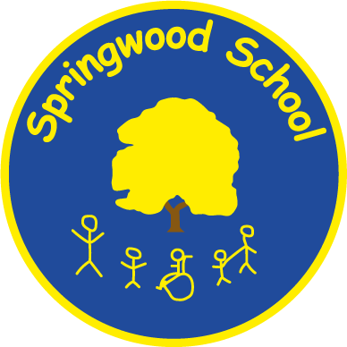

SPRINGWOOD PRIMARY SCHOOL

ADMISSIONS POLICY

Head Teacher: Mrs. Jacqui Wennington

Head Teacher: | Jacqui Wennington
Written by: | Jeanette Woodward-Styles
Date written: | October 2023
Next Review: | September 2024
Ratified by Governors: | School Improvement Committee
Date: | 7th February 2024
Published on the Website: | 19th February 2024

Introduction

Springwood Primary School serves the whole of the City of Salford and offers places for pupils aged 4 to 11 years all of whom have an Education Health Care Plan (EHCP). The school caters for pupils with severe, profound, multiple and complex needs. Some pupils also have complex medical needs.

Pupils are educated at one of three sites:

- Springwood Craig Hall, based in Irlam, for pupils in Early Years Foundation Stage and Key Stage One;
- Springwood Hub based at Summerville Primary School, for pupils in Key Stage One/Lower Key Stage Two and;
- Springwood Swinton for pupils in Key Stage Two.
The current PAN (Published Admissions Number) for the school is 340, split over all year groups in the primary phase, across all three sites.

Aims

This policy aims to:

- Provide clarity on the school admissions process into Springwood Primary School;
- Support the process of school admission for parents/carers and pupils;
- Encourage partnership working with the Local Authority (LA);
- Support pupils’ positive introduction to school.

Springwood Admissions

Pupils are offered a place at Springwood if they have severe and/or complex special educational needs which their Education, Health and Care Plan (EHCP) says can be best met within a specialist provision.

Pupils are admitted to the school in the following ways:

- Via formal assessment resulting in an EHCP being issued that identifies Springwood School as the most suitable placement;
- Via transfer from another LA on moving into the area;
- On rare occasions, pupils without an EHCP may be admitted via an assessment place. This will be in liaison with the LA.

All places at Springwood are managed by Salford LA and are agreed by the school and the LA Special Educational Needs and Disabilities (SEND) Panel.
More information about school admissions in Salford LA can be found on the Salford Local Offer website:
www.salford.gov.uk/localoffer

Visitor Days
All families are welcome to make an informal visit to the school to see our facilities, ask any relevant questions and to gain an understanding of our educational approach. Visitor days are held regularly throughout the year at our different sites.

Parents/carers can book onto a session convenient to them by contacting the office directly on
0161 778 0022:

Swinton – Option 1

Craig Hall – Option 2

Families are also actively encouraged to visit our school website, where further school information and upcoming visitor dates can be found.

Transition

Once a school place has been offered by the LA, a member of Springwood staff will make contact with parents/carers to make arrangements to support a successful transition into school. We recognise each child and their family have individual needs so the transition arrangements will reflect this.

The following guidelines, which should be read in conjunction with our school’s Transition Policy, are used to help children enjoy a safe, successful and positive admission into Springwood Primary School:

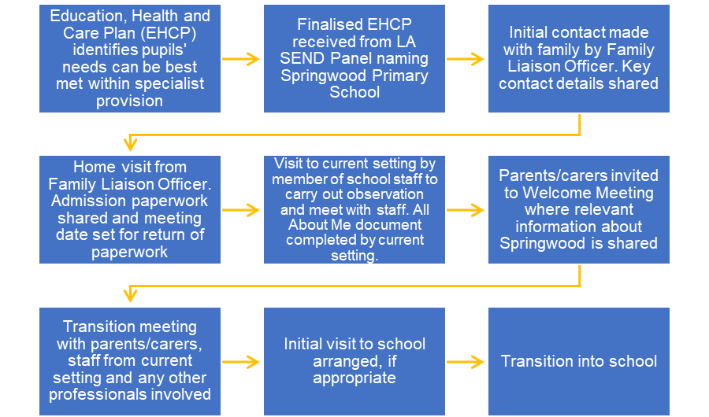

Monitoring and Review

Pupils’ EHCPs are monitored and reviewed every six months up until the age of five and then annually thereafter. Parents/carers and any professionals involved with the pupil will be invited to an Annual Review, during which discussions on progress, suitability of provision and target setting will take place. Any proposed requests for additional support or change of placement requests are sent to the LA SEND Panel for consideration. The LA will be required to inform the school of their decision before any changes can be implemented. Where no changes are required, a ‘No Change in Placement’ notification will be issued by the LA.

