

SPRINGWOOD PRIMARY SCHOOL

ASTHMA POLICY

Head Teacher: Mrs. Jacqui Wennington

Head teacher: | Jacqui Wennington
Date written: | April 2014
Reviewed by: | Matt Lawrenson/AnnMarie Walker
Review date: | June 2024
Next review: | June 2025
Published on the website: | June 2024



Introduction & Background

The 2010 Children, Schools and Families Act and the Children and Families Act 2014 introduced a legal duty on schools to look after children with medical conditions. This is inclusive of children with asthma, and it is therefore essential that all school staff and those who support younger children have an awareness of this medical condition and the needs of pupils with this condition.

This policy has been put together in collaboration with school staff, parents, School Nurses and Governors to ensure that the individual needs of pupils are being met when a child has asthma. It should be read in conjunction with Springwood’s Supporting Pupils with Medical Conditions Policy including Children with Health needs who cannot attend school policy.

This policy:

- Recognises the needs of pupils with asthma.
- Ensures that children with asthma participate as fully as possible in all aspects of school life, including, for example, Physical Education, visits, outings, and field trips.
- Ensures staff are trained in how to deal with an asthma attack.

A clear requirement from staff, parents and pupils is that a sound asthma policy improves the management of asthma in children. Underpinning this is developing awareness of how school staff can support children with asthma by an understanding of the disease and how it is managed in the school setting. For most children, asthma, when well managed at home and school should not affect their school experience.

All children with asthma will be under the care of their GP/Practice nurse or a Paediatrician and should be attending reviews every 6-12 months. The School Nurse or Specialist Health Visitor can compliment this by offering support for children in the school setting or at home.

The following policy enables school to meet the needs of their school community whilst ensuring that National Guidelines for the management of asthma in children are followed.

School Name | Springwood Primary School
Head Teacher / Principal Name | Jacqui Wennington
Asthma Lead Name & Job Role | Deputy Head Teachers
School Nurse / Link Nurse Name | Helen Byrne/ Sophie Monk
School Nurse / Link Nurse  Contact Number | 0161 206 1776
Medication Storage Location (if located in classrooms list individually)

All classrooms have a locked medical cabinet in which they keep any prescribed medications for pupils, including inhalers.

Emergency Asthma Inhaler Storage Location (if applicable)
Reception areas at all three sites.

Asthma Register Storage Location
Reception areas at all three sites.

School Asthma Policy

Asthma

Asthma is a condition that affects the airways – the small tubes that carry air in and out of the lungs. When a child or young person with asthma comes into contact with an asthma trigger, the muscles around the walls of the airways tighten so that the airways become narrower. The lining of the airways becomes inflamed and starts to swell. Sometimes, sticky mucus can be produced. All these reactions cause the airways to become narrower and irritated – leading to the symptoms of asthma. Children and young people with asthma have airways that are almost always red and sensitive (inflamed). These airways can react badly when they encounter something that irritates their airways (an asthma trigger).

The usual symptoms of asthma are:
• Coughing,
• Shortness of breath,
• Wheezing,
• Tightness in the chest,
• Being unusually quiet,
• Difficulty speaking in full sentences,
• Sometimes younger children will express a tight feeling in the chest as a tummy ache.

A trigger is anything that irritates the airways and causes asthma symptoms. There are many asthma triggers. Everybody’s asthma is different and everyone will have different triggers. Common triggers include viral infections (colds and flu), house-dust mites, pollen, cigarette smoke, furry and feathery animals, exercise, outdoor air pollution, laughter, excitement, and stress.

Springwood Primary School acknowledges that asthma is the most prevalent disease of childhood and recognises that many pupils enrolled in this school will have the disease.

Their disease should not isolate asthma sufferers; therefore, asthma awareness should involve ALL members of the school community.

Roles and Responsibilities

The Local Governing Board are responsible for ensuring there is an effective policy in place that is followed. Further to this:

Parents/Carers responsibilities
- Inform the school if their child has asthma.
- Inform the school of any changes to their child’s condition; parents will be prompted by an annual letter via our school app (Appendix 1).
- Ensure their child has an up-to-date written Personalised Asthma Action Plan (PAAP) Appendix 2) from their doctor or specialist healthcare professional and that they share this with the school, where this is required.
- Ensure their child has regular reviews (at least annually and after each exacerbation) with their doctor or specialist healthcare professional.
- Ensure in date medicines come into school on the first day of the new academic year. Spacers need to be replaced annually if used regularly.

School Leadership & Teachers’ Responsibilities
- The School Leadership Team should ensure that the school’s Asthma Policy is read and understood by all members of staff working with pupils.
- The school Asthma Policy will be shared and available to parents on the school website
- Be aware of the potential triggers, signs and symptoms of asthma and know what to do in an emergency.
- Know which pupils have asthma and be familiar with the content of their Personalised Asthma Action Plan.
- Allow all pupils to have immediate access to their emergency medicines.
- Inform parents if a child uses their inhaler after an exacerbation.
- Encourage parents to seek a clinical review if a child regularly uses their inhaler at school.
- Maintain effective communication with parents including informing them if their child has been unwell at school.
- Be aware that asthma can affect a pupil’s learning and provide extra help when needed.
- Use opportunities such as Personal Social Health Education (PSHE) to raise pupil awareness about asthma.
- Understand asthma and the impact it can have on pupils (pupils should not be forced to take part in an activity if they feel unwell). If school identify a pattern or are concerned about an individual pupil, they will inform their parent/carer and make the school nurses aware.
- Ensure pupils with asthma are not excluded from activities in which they wish to take part.
- The School Leadership will review the Asthma Policy annually and conduct an annual review of the safe management of asthma in the school.
- Ensure that pupils with asthma don’t use materials or, where possible, do not come into contact with any materials that may trigger asthma symptoms such as perfumes, dust, moulds, smoke, air fresheners etc

School Asthma Leads Responsibilities (DHTs)

The school Asthma Leads have delegated responsibility by the Head Teacher and school governors to ensure:
- There is an adequate supply of emergency kits and know how to obtain these from their local pharmacy.
- Procedures are followed.
- The asthma register is up-to date and accessible to all staff.
- All children on the register have consent status recorded, an inhaler, a spacer, and a care plan.
- That medication use in school is monitored. For any salbutamol inhaler use during the school day, apart from pre-agreed sport use, parents should be informed. If a pattern of regular use is emerging at school for example, if a child was using their rescue inhaler three times a week – the School Nurse (or Asthma Nurse Specialist if family already has links) should be informed. The School Nurse should then liaise with the child’s GP/Practice Nurse or Specialist.
- Expiry dates are checked at least every half term and impending expiry dates are communicated to parent/guardian.
- Replacement inhalers are obtained before the expiry date.
- Empty/out of date inhalers are disposed of appropriately
- Their own training is up to date.
- The school’s policy and practice is reviewed annually.
- Emergency kits are checked regularly and contents replenished immediately after use.

Asthma Leads will ensure that appropriate regular training is provided for staff who are required to support pupils with asthma.

All Staff Responsibilities
- Attend asthma training yearly.
- Know what the procedures are and which pupils have asthma, be familiar with their care plans.
- Inform the Asthma Leads if a school emergency inhaler has been used.
- Record the usage in the main asthma register located in the school office if the school’s emergency inhaler has been used.
- Ensure all pupils with asthma have easy access to their reliever inhaler and spacer
- Encourage all pupils to carry and administer their own inhaler when their parents and health care provider determine they can start taking responsibility for their condition.
- Ensure all staff attending off site visits are aware of any pupils on the visit with asthma and have brought their medication. They should be trained what to do in an emergency.

Identification of pupils affected:

- At the beginning of each school year or when a child joins the school parents/carers will be asked to complete the school’s admissions booklet, which includes medical conditions.
- Treatment details should always be given to school and accessible by staff.
- It is the responsibility of parents or carers to notify school if their child has asthma.

Treatment of Asthma

Reliever Inhalers:

Every child with asthma should have a reliever inhaler (usually blue). Relievers are medicines that can be taken immediately when asthma symptoms start. They quickly relax the muscles surrounding the narrowed airways. This allows the airways to open wider, making it easier to breathe again.
- Relievers are essential in treating asthma attacks,
- Reliever inhalers are usually blue.
- It is very important that a pupil with asthma has a reliever inhaler that they can use reliably and effectively.
- Relievers are a very safe and effective medicine and have very few side effects. Sometimes, children do get an increased heart rate and may feel shaky if they take a lot. However, children cannot overdose on reliever medicines and these side effects pass very quickly
- All inhalers have an expiry date. Parents/carers should be responsible for ensuring that all their child’s asthma medicines are within the expiry date. Reliever inhalers and preventers usually last about two years.

Preventer Inhalers:

Preventers protect the lining of the airways. They help to calm the swelling in the airways and stop them from being so sensitive. Taking preventer medicines means that a child with asthma is less likely to react badly when they come into contact with an asthma trigger. However, not all children with asthma will need a preventer inhaler.

- Preventers are usually prescribed for children who are using their reliever inhaler at least three times a week.
- Preventers reduce the risk of severe attacks.
- Preventer inhalers are usually brown.
- The protective effect of preventer medicines builds up over time, so preventers need to be taken every day (usually morning and evening), even if the child is feeling well.
- At school, children should not normally need to take the preventer inhaler during school hours.

Spacers:

A spacer is a plastic chamber with a mouthpiece at one end that may have a mask attached, and a hole for an aerosol inhaler at the other end. Spacers are helped to deliver medicines to the lungs. They make inhalers easier to use and more effective. Spacers are used with aerosol inhalers. At school, spacers may often be needed and used at school, especially by pupils under the age of 12. Each pupil, who has been prescribed a spacer by their doctor or asthma nurse, should have their own individually labelled spacer. This should be kept with their inhaler.

Access to Inhaler

Treatment in school will always be by an inhaled method. Pupils in Primary Schools are more likely to get relief during an exacerbation by using a spray inhaler WITH spacer device.

Access to treatment is vital and children are encouraged by Asthma UK to assume individual responsibility for their inhalers as soon as possible. Children will need help and supervision when taking their inhalers.

As a general rule only BLUE reliever inhalers need to be brought to school. Parents should be encouraged to obtain a ‘spare’ inhaler and spacer device, if required, to be kept for use at school only and to make a note of the expiry date and when it needs replacing.
Spacer devices will ensure that inhalers reach the lungs and will be more effective.

These inhalers should be clearly labelled with the child’s name and kept in the medicine cupboard in class (ensuring all inhalers are logged in to medicine cupboard as per medicine policy).

Schools may wish to decide the frequency for renewal and cleaning of devices. It is recommended that they are taken home at least once a year to check the expiry date and its cleanliness.

The emergency inhaler kit

The emergency inhaler kit is kept in the reception area at all three sites and Senior Leaders must be informed by staff before use.

An emergency asthma inhaler kit should include: -
- a salbutamol metered dose inhaler; -
- at least two plastic spacers compatible with the inhaler.
- instructions on using the inhaler and spacer.
- instructions on cleaning and storing the inhaler.
- manufacturer’s information; -
- a checklist of inhalers, identified by their batch number and expiry date, with monthly checks recorded.
- a note of the arrangements for replacing the inhaler and spacers
- Guidance on the use of emergency salbutamol inhalers in schools
- a list of children permitted to use the emergency inhaler as detailed in their individual healthcare plans.
- a record of administration (i.e. when the inhaler has been used).

Use of emergency Salbutamol Inhalers in school

As of the 1 October 2014 the Human Medicines (Amendment) Regulations 2014 has allowed schools to obtain, without prescription, salbutamol inhalers to use in emergencies.

The inhaler can only be used for any pupil who has been prescribed one for asthma or as a reliever medication, providing there is written parental consent for the use of the emergency inhaler.

The inhaler can be used if the pupil’s own prescribed inhaler is not immediately available, for example if it is expired or broken.

The school emergency inhaler does not replace the child’s own inhaler. If a child is prescribed an inhaler, one should still be provided for school use.

For further information regarding what to do in an asthma attack, see Appendix 3.

Supply and Storage

Inhalers will be purchased from a local pharmacy or from the school’s current medical supplier.
All inhalers will be kept in an emergency asthma inhaler kit which will be housed in the Admin office on both school sites. A folder containing paperwork and guidance will be kept alongside the kit.

The emergency kits will be checked on a regular basis to ensure that the inhalers are still in date.

Procedure for administration of emergency Salbutamol inhaler.

Parents inform school child
has been diagnosed with Asthma or prescribed a reliever inhaler

Parents complete
Parental Agreement and consent for school to administer an emergency inhaler
(Appendix 1)

School will
Keep a register of pupils who have been prescribed an inhaler, generated on the Arbor Pupil Information System, with a printed copy kept with the emergency medication

School will
Keep a record of the use of any emergency inhaler on CPOMS and inform parents/carers
that it has been administered

(Appendix 5)

Prevention of Exacerbations

The health benefits of exercise for children with asthma are well documented and their participation must be encouraged. Many children with asthma have symptoms, which are provoked by exercise and therefore require their reliever inhaler to be available if they are taking part in any form of physical exertion, including PE lessons, swimming, sports days and exercise undertaken in playground situations. Part of the action plan given by the doctor or nurse to children with asthma, is to use their relief medication approximately ten minutes prior to exercise if they experience symptoms.

All children with asthma should be encouraged to take part in activities at school.

Warm up exercises both before and after exercise, are helpful for children who experience exercise-induced asthma.

Out of School Activities

It is essential that pupils with asthma have access to their inhalers and should therefore always be taken with them, particularly as the child may be exposed to triggers e.g. excitement, more vigorous exercise, exposure to grasses and pollens and animals. This of course includes residential school holidays, which will necessitate the inclusion of preventer inhalers (usually brown or less commonly orange or purple in colour) and parents should provide instructions (action plan) about what the child needs each day.

Recognise the signs of an asthma attack
An asthma attack happens when your child’s asthma symptoms get much worse.
This can happen quite suddenly or can build up gradually over a few days.

Your child might:
- find it hard to breathe
- breathe more quickly
- be unable to talk or walk or eat
- wheeze and cough a lot
- complain of a tight chest or a tummy ache
- say their blue reliever inhaler isn’t helping, or they need it more than every four hours
- be unusually quiet.

Actions to take if a pupil has an asthma attack

- Stay calm – it is treatable
- Sit the child comfortably – do not let the child lie down
- Do not crowd the child
- Speak quietly and calmly to the child – encourage slow deep breaths.
- Do not put your arms around the child’s shoulders – this restricts breathing.
- If this works-contact parent/carer who should come to school to follow the action plan regarding the need for medical attention.
- The BLUE inhaler should last for 4 hours. Needing it more frequently may be a sign of worsening asthma and parents/carers should be contacted immediately.

Actions to take if a pupil has a severe asthma attack
- Help them to sit up – don’t let them lie down. Try to be calm
- Help them take one puff of their reliever inhaler (with their spacer, if they have it) every 30 to 60 seconds, up to a total of 10 puffs
- If they don’t have their blue inhaler, or it’s not helping, or if you are worried at any time, call 999 straightaways. This constitutes an emergency
- While you wait for an ambulance, your child can use their blue reliever again, every 30 to 60 seconds (up to 10 puffs) if they need to.
- You cannot overdose the child by doing this but inform the paramedic how much inhaled therapy has been administered.

References

Asthma.org.uk

Appendix 1: Parental Agreement and consent for school to administer an emergency inhaler

Parental Consent Form

FOR USE OF EMERGENCY SALBUTAMOL INHALERS IN SCHOOL

Pupil Name:______________________________

Class: __________________________________

Daytime telephone number of parent/adult contact: ________________________

Name and phone number of GP: ______________________________________

1. I can confirm that my child has been diagnosed as having asthma or has been prescribed a reliever inhaler.

2. My child has a working, in-date inhaler, clearly labelled with their name, which is available in school.

3. In the event of my child displaying symptoms of an asthma attack, and if their inhaler is not available or is unusable, I consent for my child to receive the use of a salbutamol inhaler held by the school for emergencies.

The above information is, to the best of my knowledge, accurate at the time of writing and I give consent to school/setting staff administering medicine in accordance with the school/setting policy. I will inform the school/setting immediately, in writing, if there is any change in dosage or frequency of the medication or if the medicine is stopped.

Parent/Carer Signature: __________________________

Print Name: ____________________________________

Appendix 2: Personalised Asthma Action Plan (PAAP)

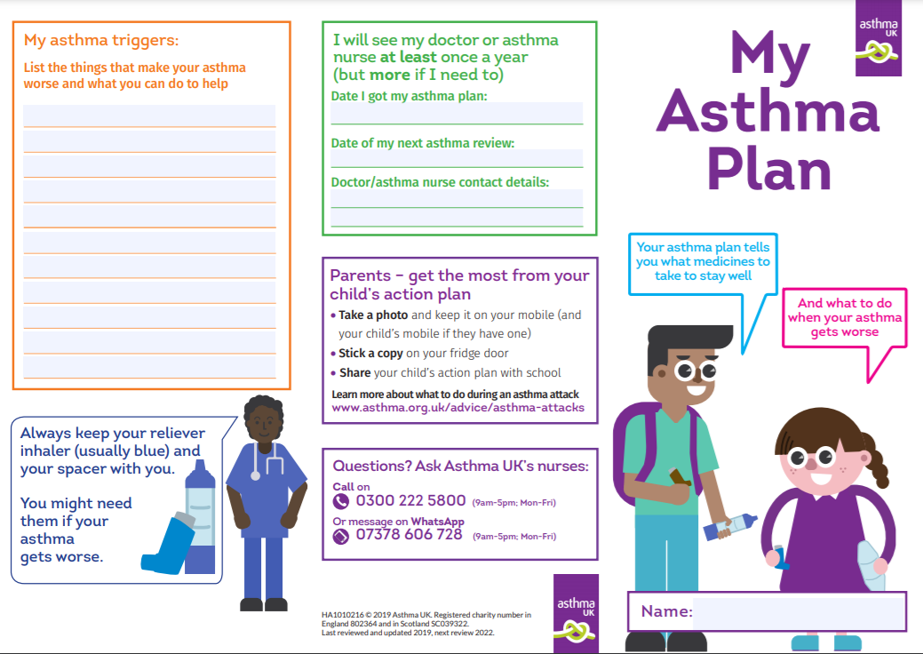

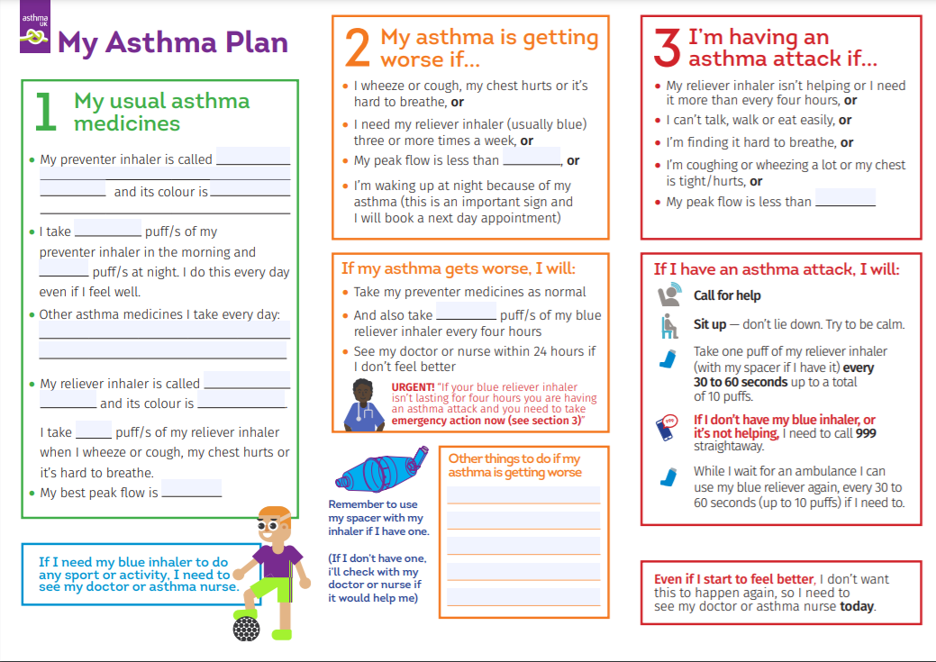
Appendix 3: How to recognise an asthma attack

The signs of an asthma attack are:
- Persistent cough (when at rest)
- A wheezing sound coming from the chest (when at rest)
- Difficulty breathing (the child could be breathing fast with effort, using all accessory muscles in the upper body)
- Nasal flaring
- Unable to talk or complete sentences. Some children will go very quiet.
- May try to tell you that their chest ‘feels tight’ (younger children may express this as a tummy ache)

CALL AN AMBULANCE IMMEDIATELY AND COMMENCE THE ASTHMA ATTACK PROCEDURE WITHOUT DELAY IF THE CHILD
- Appears exhausted
- Has a blue/white tinge around the lips
- Is going blue
- Has collapsed
What to do in the event of an asthma attack

- Keep calm and reassure the child.
- Encourage the child to sit up and slightly forward
- Use the child’s own inhaler – if not available, use the emergency inhaler
- Remain with the child while the inhaler and spacer are brought to them
- Immediately help the child to take two separate puffs of salbutamol via the spacer
- If there is no immediate improvement, continue to give two puffs at a time every two minutes, up to a maximum of 10 puffs.
- Stay calm and reassure the child. Stay with the child until they feel better. The child can return to school activities when they feel better.
- If the child does not feel better or you are worried at ANYTIME before you have reached 10 puffs, CALL 999 FOR AN AMBULANCE.
- If the ambulance does not arrive in 10 minutes give another 10 puffs in the same way.

Appendix 5: Parental Notification of Emergency Salbutamol Inhaler Use

Pupil Name:

Class:

Date:

Dear

This letter is to formally notify you that ____________________________ has shown symptoms of an asthma attack today and has had trouble with their breathing.

This happened when ______________________________________________

A member of staff helped them to use their inhaler/ they did not have their own inhaler with them/ their own inhaler was not working, so they were administered with the emergency inhaler.

They were given ____ puffs.

Although they soon felt better, we would strongly advise that you have your child seen by your own doctor as soon as possible.

Yours sincerely

