September: Harvest Festival.  Help prepare a healthy snack. Look at the different healthy items you could choose and try them.  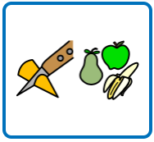  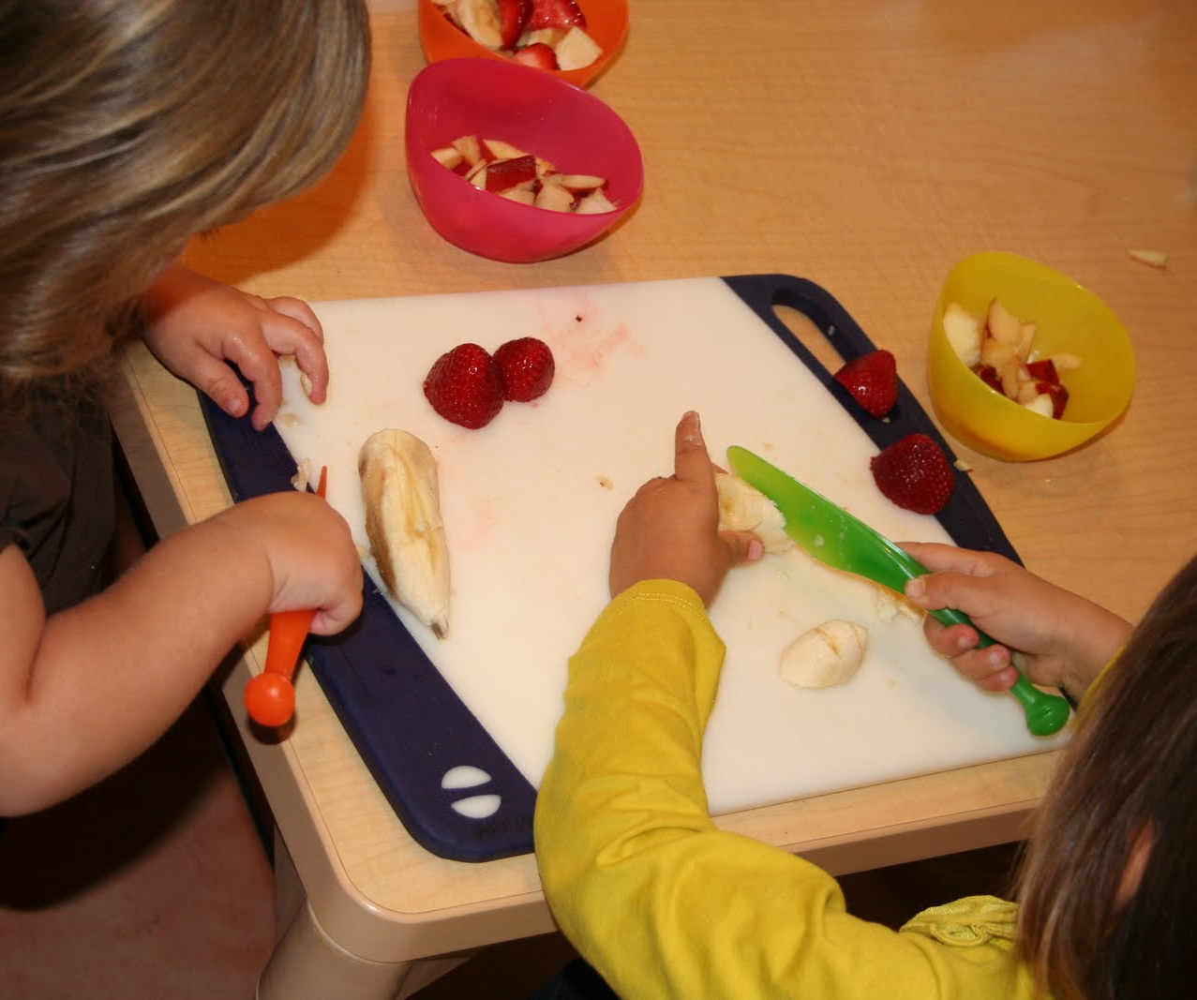 | September: Roald Dahl Day  Visit a library and pick a book to share with your family.  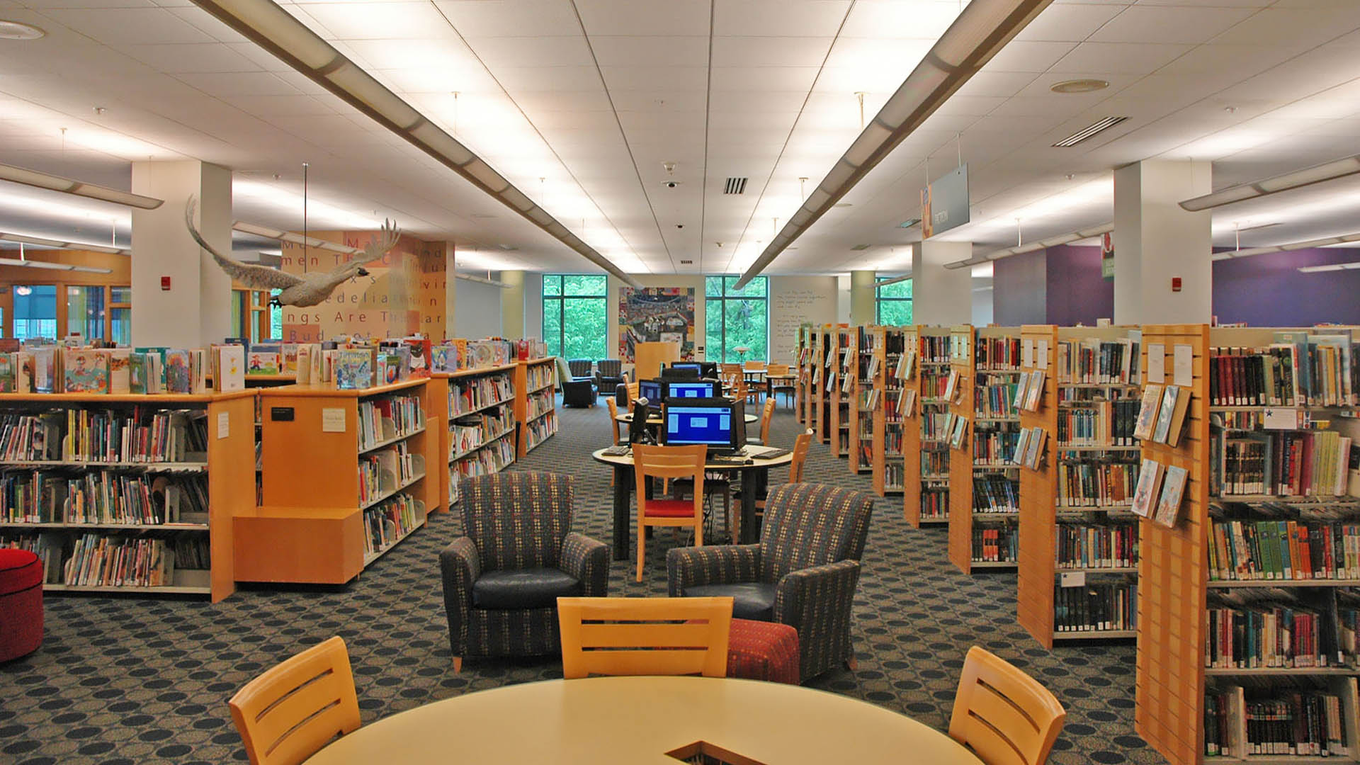 | October: Halloween.  Carve a pumpkin for Halloween.  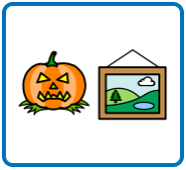  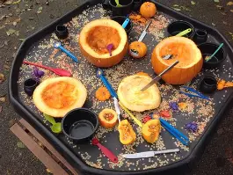
November: Bonfire Night.  Make your own firework pictures.  You could paint, use an app, or even take your own photos at an event.  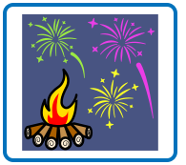  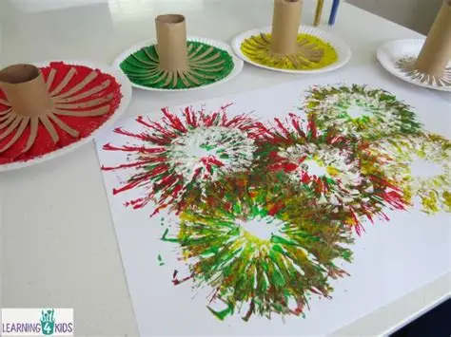 | 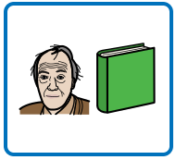  November: Diwali.  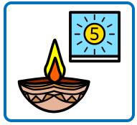  Make lanterns for the festival of Diwali. Make it as colourful as you can choose different colours to make it bright and colourful.  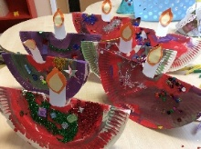 | November: Remembrance Day.  Make your own poppy or even attend a Remembrance Day parade.  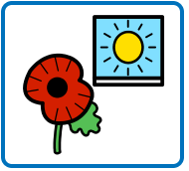  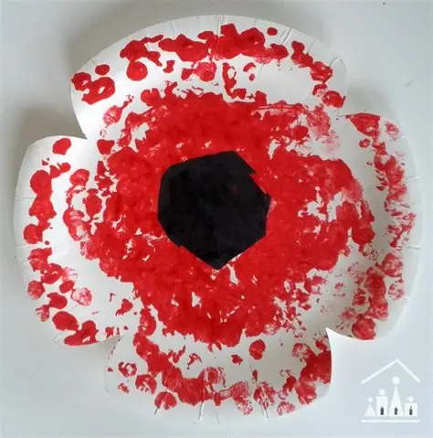
December: Hanukkah.  Maths challenge. A menorah is lit over 8 nights. Can you count how many candles are lit on Night 1, Night 2 and Night 3?  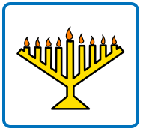  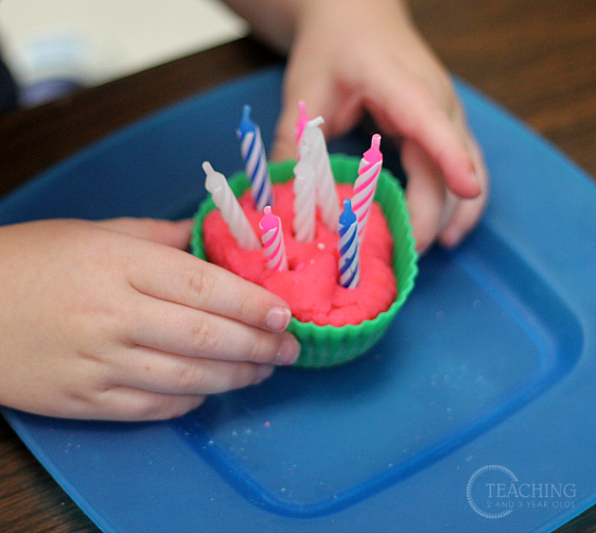 | December: Christmas  Create a Christmas list, using pictures from a catalogue or even write it.  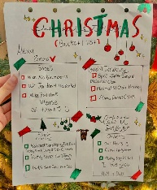  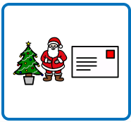 | Autumn/Winter walk  Go for a walk in the local community and see how it changes in Autumn and Winter.  .