September: Harvest Festival.  Feel, smell, and look closely at different foods.  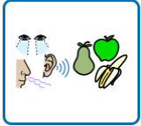 | October: Halloween.  Join in with carving a pumpkin or create a spooky picture using paint, collage, or sensory materials.  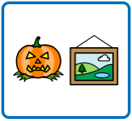 | November: Bonfire Night.  Watch how fireworks move and change shape in the sky or on the iPad.  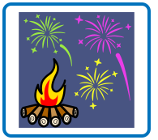
November: Diwali.  Notice how different colours and light sources make patterns and shadows.  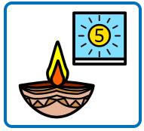 | November: Remembrance Day.  Show preferences for materials and colours through looking, pointing, reaching, signing, or vocalising.  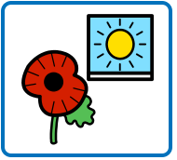 | December: Hanukkah.  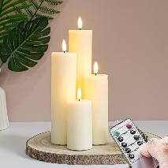  Watch electric candles being switched on one by one.  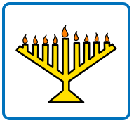
December: Christmas  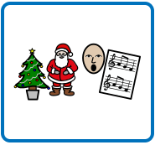  Join in with singing Christmas songs, using actions, musical instruments, or movement. | Autumn/Winter walk  Go for a walk in your local community and look for signs of Autumn and Winter. Show your likes and interests by looking, pointing, reaching, signing, or vocalising.  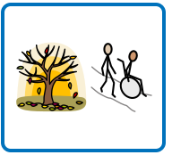 | Story time  Listen to a favourite story with your favourite people at home.  

