September: Harvest Festival.  Practice our cutting skills whilst preparing a healthy snack.  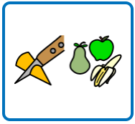  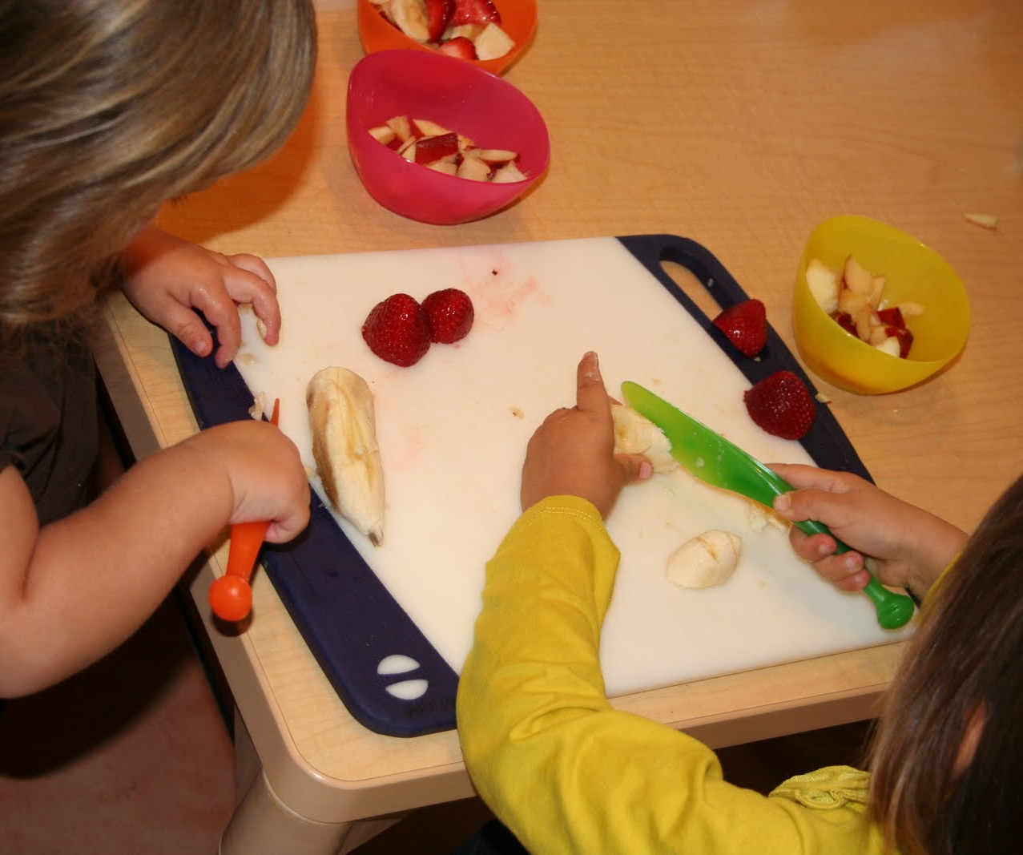 | October: Halloween.  Carve a pumpkin or make a spooky picture for Halloween.  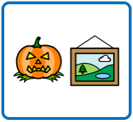  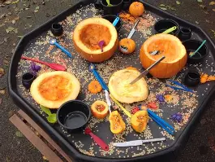 | November: Bonfire Night.  Make your own firework pictures.  You could paint, an app, or even take your own photos at an event.  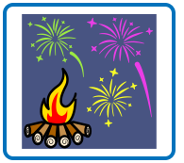  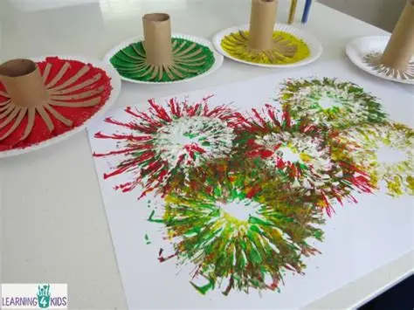
November: Diwali.  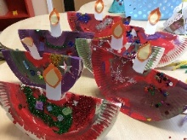  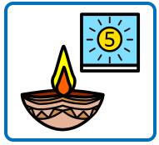  Make laterns for the festival of Diwali (November). You can choose different colours to make it bright and colourful. | November: Remembrance Day.  Make your own poppy, using a paper plate.  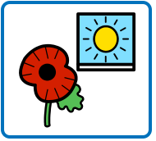  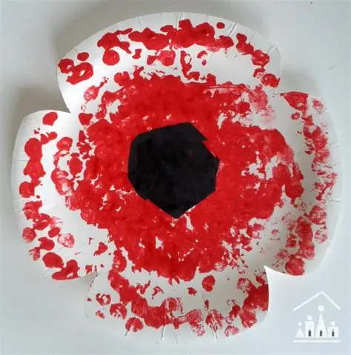 | December: Hanukkah.  Counting candles for the menorah. You could use birthday, roll playdough or even paper candles.  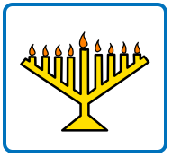  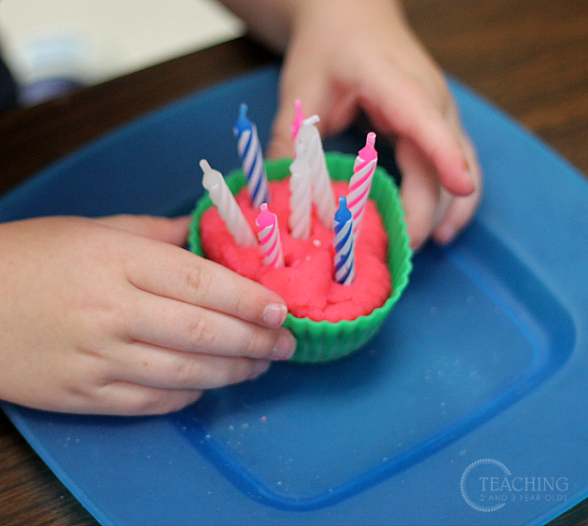
December: Christmas  Listen/sing some Christmas songs.  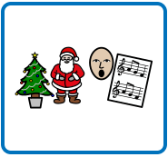 | Autumn/Winter walk  Go for a walk in the local community and see how it changes in Autumn and Winter.  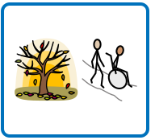 | Story time  Read your favourite book together with family and friends.  

